newsletter
volume 9 issue 1 31 march 2010

‘Gotong Royong Utrecht’ Foundation

postal address: oudkerkhof 15 bis, 3512 GH Utrecht, the netherlands
email: info@gotong-royong-utrecht.nl
bank account: 84.21.36.932 (FORTIS)
reg.number chamber of commerce H30179877

1. From the board

Spring has started, the days are getting longer, all creatures are crawling out of their holes after a long winter sleep and Ratna, our Bali station of support, has given birth to twin sisters! We closed the accounts of the year 2009: we did it again! although there are a few worrisome developments. We will not complain or exert moral pressure, but we must confess 2010 will be an exciting year, financially speaking.
The crisis went on in 2009 and a huge disaster took place in Haiti in January. Instant help was needed and fortunately many funds were raised, but possibly because of this less attention was paid to other organisations, like ours. Which, of course, we fully understand.
Indonesia is, surprisingly, one of the countries that suffered less from the world crisis. The economic policy is effective. As a result the local currency, the Rupiah, has risen, so we now get 20% less for every euro we receive. Now there’s a challenge..
The activities that are most under pressure now are those not sponsored by other organisations: scholarships, nursery and senior citizens. The senior citizens project cannot easily be made ‘sustainable’ or, in the end, self-supporting. The project has no end, except for the passing away of an elderly person, the exact thing we are trying to postpone by giving additional food and medical care. The project does not meet the requirements of NGOs. The same applies to the scholarship project and the nursery: no other organisations are interested in this kind of one-to-one aid. Fortunately there is a foundation that donates half of the money needed yearly for scholarships, provided we first acquire the other half ourselves (preferably between April and May)!
In short: we depend on private gifts: of friends, family, (ex)colleagues, visitors and all others interested!

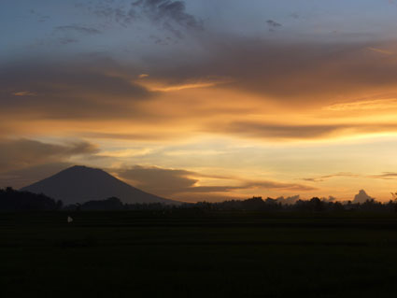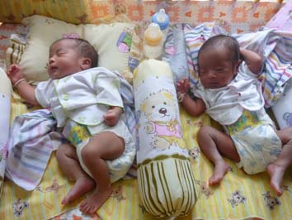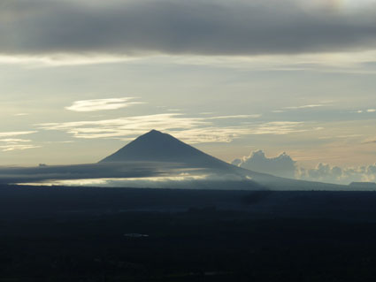
Dark times Ratna’s girls Light in the darkness

We need your help! Maybe there are people in your circle of friends who sympathize with us. Do feel free to send them this newsletter!

2. Project information

I. Bali: Widhya Asih III children’s home, Singaraja

Yohanes and the children are doing well. In December the children finished their first semester exams. Most did fine, some even very good, only a few did less well. The children’s home receives a lot of visitors and many of them stay in the bungalows on the home’s grounds for a few nights. At this moment there are a couple of students from Singapore who take care of English lessons. If this is successful, other students will follow to continue this project. Production of batik and rosella tea is continuing, we even received orders from the Netherlands and the US. The production of oyster mushrooms had temporarily been put on hold.
The students are all doing well. We especially want to mention Derlianti who finished the first semester third of her class and received a 1 juta (the equivalent of 80 euros) scholarship, and Artana who is in his last but one year of art school and scored only As (the highest score). Meanwhile there are at least four candidates for the next school year: one for theology in Yogja (we are trying to persuade the local church to sponsor her), two for the Polytechnic school in Denpasar and one for nursing school in Yogja. Who helps us to support these talented youngsters?

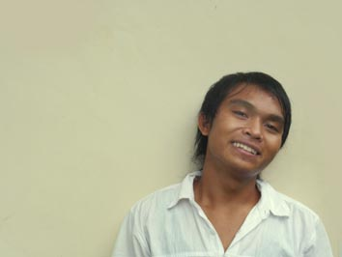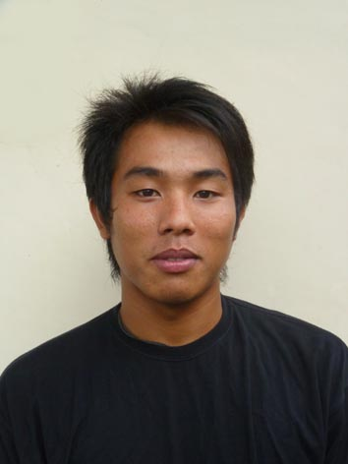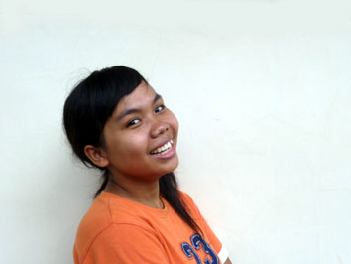
Restiada Suarcaya Trifena Artana (self portrait)

II. Bali: Scholarships

In January and February we visited all children at their schools to make an inventory of their wishes, which we can fully fulfil (okay, some had to be disappointed by the fact that watches are not considered necessary school equipment or by receiving Aditas shoes in stead of Adidas).

III. Bali: Seniors and medical support

Saddened we had to say goodbye to two seniors in the Bali group. Ibu Sekarning and Bpk Sindu have passed away. Their places were taken by two candidates from the waiting list. Like the children’s home the seniors group also receives many Dutch visitors. Every month there are guests visiting the group meetings. Apart from the meetings we give one-to-one support where needed, enabling seniors to pay for doctor’s or specialist’s visits. At the moment Bpk Gede Ngurah (stroke) and Ibu Suresemi (Parkinson’s disease) receive our help.

Our support to the Hidup Bahagia group will be continued in 2010 because we found an organisation willing to fund it. 4000 euros is available for medical support for these psychiatric patients who were formerly put away without receiving any care. There is a new video. The journalists who made the first video (click while pressing the CTRL-button) returned after a year to meet the same patients and make a second video. More information can be found in a Jakarta Post article.

IV. Java: Yogyakarta- Community development.

In March Gajah Mada University students finished two surveys of the regions Nogosari near Imogiri and Wukirhardjo in the Prambanan hills where an ‘integral project’ might be possible: MCKs, road paving, public lighting and microcredits. After discussing the surveys we chose a low profile approach: not announcing all our plans, but starting with an MCK (which is needed beyond all doubt) to see how the cooperation evolves. But first money has to be asked for.

V. Java: Yogyakarta; Seniors and medical support

The project is doing well. The volunteers are enthusiastic and the seniors are happy with the care and attention given. Apart from the worries mentioned above, the risen prices of rice and sugar put heavy pressure on the budget.

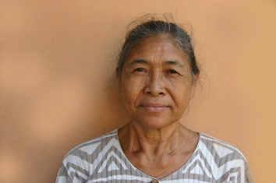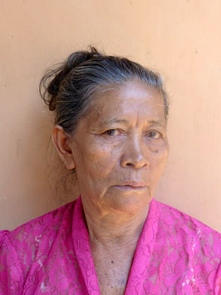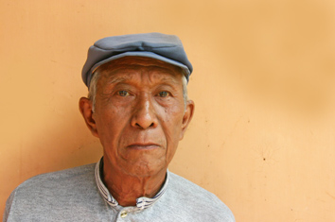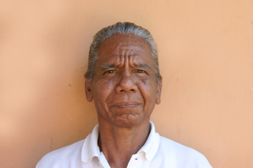
Bu Seresemi Bu Nyoman Arini Bpk Sindu (RIP) Jero Mangku Putu Dalem

VI. Java: Yogyakarta; Scholarships

The first semester is finished and the children received the requirements for the second semester: clothing, shoes, books and if needed money for additional lessons. The final classes of the junior and senior highschool (SMP and SMA) just finished their national exams and will start the local exams in three weeks’ time. Agung, who is in nursing school, finished his internship; RS Nur Hidaya offered him a job after he finishes his studies!

VII. Java: Community Activity Centre -Roemah Kita- ; nursery (PAUD)

The nursery is doing fine with plenty of participants. The seniors group and the staff requested we start a pre-school play group (an unofficial kindergarten). The board is in favour of this: optimum use of knowledge, skills, space and enthusiasm. It can be done in the same building, with some adjustments for which a budget is presented. We are know searching for the money needed.

VIII. Java: MCKs (public wash/bathrooms)

In January, February and March another three MCKs were finished, all in Nogosari I and II (pictures on the next page). One next to a kindergarten school (that did not have a toilet) and one in RT 04 near an old well that used to be contaminated. And we keep on building! as long as our MCK-sponsor continues its support. And we spotted a new trend: several friends from the Netherlands supporting the building of an MCK. For this year already two are planned and one is promised! At this moment two ‘normal’ MCKs are being built, also in Nogosari (twelve villages lying scattered on the Imogiri hills).

IX Java: Hospital

Hastuti (13 years old, picture on next page) is doing much better. For almost two and a half years she has been suffering from infections after complex leg fractures. The healing goes slowly but steadily. There are new applications: we met the candidates and reviewed their social situation. One patient already received surgery, two others (women with malignant tumours) were postponed, their blood pressure has to be in order first.

3. Sponsor visits !!!

An unusual busy start of the year. And fun! It started with a visit of Anne and Christien and shortly afterwards Ine en Pieter; all stayed in the bungalow at the children’s home. After this Maltie en Dolf arrived and at the end of March Ankie, Koos, Tineke en Trijn. Thank you very much for your visits and gifts!

4. Couleur locale

March 2010: on Bali as well as in Yogjakarta it is too hot and too dry. This will cause problems in the period of August – November because the crater lakes are not sufficiently filled with water. At the same time Bandung and Jakarta are suffering from big amounts of rain, causing a lot of inconvenience and damage. Economically it is going well: even more tourists than previous years come to Bali (58% more Australians than last year). Politically it is a bit turbulent: an old conflict between president Yudhoyono and Megawati (notoriously bad at losing) reappeared. In the meanwhile the anti-corruption brigade catches one big ‘fish’ after another. After the bank managers now it’s mainly business men who bought votes from government officials to get elected governor or to manipulate tender procedures. A district attorney talking to a business man and a high police officer about forging a file to get an anti-corruption brigade member arrested, said (not knowing the conversation was taped): “Who do they think they are? What a nerve for a cicak (small lizard) to think it can attack a crocodile!” But indeed, it can!

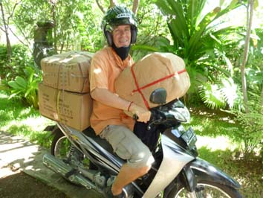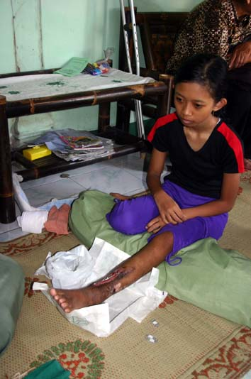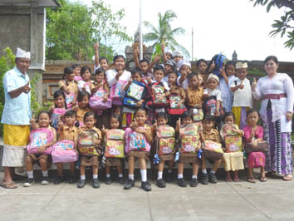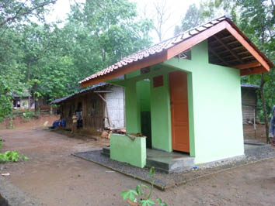
Scholarship-deliveries Hastuti the children of SD Paket Agung MCKNogosari I Rt 5 finished

5. Sponsor possibilities

If you decide to support the initiatives of Gotong Royong financially, first think if you want to help any specific project or if you want to leave the spending to us.

Possibilities:
- the scholarship programme: one scholarship is € 50 (primary school) € 85 (junior high school) or € 110 (senior high school) a year and can start any time during the year,
- sponsoring a child of the children’s home for € 12 a month (€ 36 a quarter or € 144 a year) for complete sustenance,
- the support of a senior (60 plus) for € 10 a month (especially for vitamins, minerals and medical care). This is € 30 a quarter or € 120 a year,
- the support of a child in the Roemah Kita nursery for € 10 a month.
- the support of mentally ill patients by paying their monthly medication: € 14 a month

Of course you can also send us a free gift and leave the spending to us.

6. Gifts

Gifts are more than welcome at our bank account in Holland (Fortis): 84.21.36.932 (for the attention of Stichting Gotong Royong - Utrecht). For people who want to donate and who are living outside Holland, please contact us by e-mail so we can find a proper method of transaction for your donation.

7. Tell a friend

Please would you do us a favour and send this newsletter to your family, friends and colleagues or draw their attention to our website: www.gotong-royong-utrecht.nl where this newsletter is published as well (in English and in Dutch)!

8. Email & website

If you want to let us know something, if you have feedback, do you want to ask anything? Send us an email:
info@gotong-royong-utrecht.nl

And have a look at our website, with many photos of our projects:
www.gotong-royong-utrecht.nl

